To use the site you please fix File :

TheCakeWebsiteProject\src\java\Connect\DBUtility.java

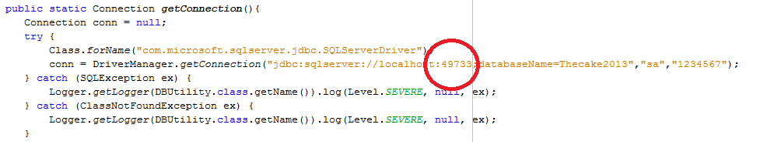
Please change local host :

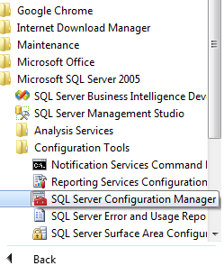

You Choose

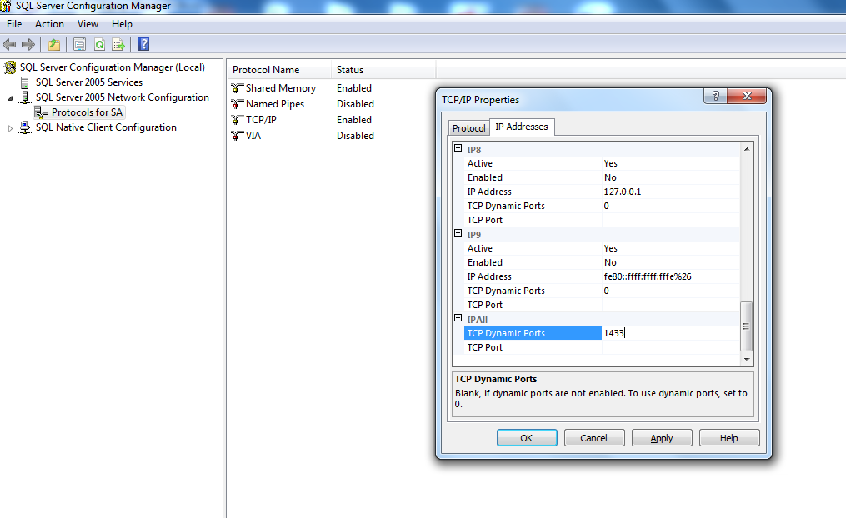

Your coppy and change localhost

EXAM:

….Sqlserver://localhost:1433;databaseName=….

--------------Thank you for using------------

